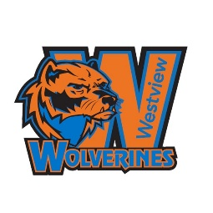
Westview Athletics

Fall Sport

Boys Cross Country
Head Coach – Mr. Matthew Moore

Girls Cross Country
Head Coach – Mrs. Lily Malcom

Football
Head Coach – Mr. Ben Ryan

Girls Golf
Head Coach – Mr. Aaron Kuecker

Softball
Head Coach – Mrs. Katie Palmquist

Boys Tennis
Head Coach – Mr. Stan Shaw

Volleyball
Head Coach – Mrs. Ashlee Clements

E-Sports
Head Coach-Louis Wacker

Winter Sports

Boys Basketball
Head Coach – Mr. Patrick Freeman

Girls Basketball
Head Coach – Mr. Jason Simons

Boys and Girls Bowling
Head Coach – Mr. Noah McKeever

Boys Wrestling
Head Coach – Mr. Kevin Modrell

Girls Wrestling
Head Coach – Mr. Colton Wolfe

Girls Swimming & Diving
Head Swim Coach – Ms. Shelbi Sisson
Head Dive Coach – Lauren Mende

Boys Swimming & Diving
Head Coach – Mr. Noah Lee

Unified Bowling
Head Coach – Ms. Christina Kloeckner

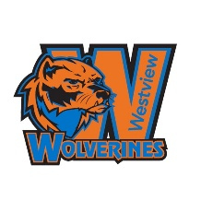

Spring Sports

Baseball
Head Coach – Mr. Scott Hodges

Boy’s Golf
Head Coach – Mr. Aaron Kuecker

Boys Soccer
Head Coach – Mr. Dean Limbach

Girls Soccer
Head Coach – Mrs. Taylor McKeever

Girls Tennis
Head Coach – Mr. Stan Shaw

Boys Track & Field
Head Coach – Mr. Matthew Moore

Girls Track & Field
Head Coach – Mrs. Lily Malcom

Unified Track & Field
Head Coach – Ms. Sydney Benson

E-Sports
Head Coach-Louis Wacker

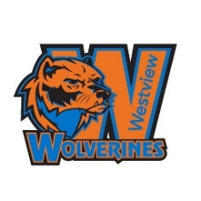
Westview Clubs/Organizations/Activities

Academic-Related

Math/Chess Club
Mr. John Hjelle and Mr. Steve Steinbruck

-work on challenging math problems with the potential to compete locally in math and chess

Book Club
Ms. Stacy Rice

-read and discuss current young adult novels, both digital eBooks and traditional paper

Speech and Debate
Ms. Sterling Frederick

-create argumentative speeches and perform them competitively

Journalism & Sports Media
Mrs. Shelby Schmidt

-cover Westview events through writing, video, and photography

National History Club
Ms. Kaylee Thompson
-provides time for students to learn their favorite parts of history. Traveling, competing, and watching movies are just perks!

Fine Arts-Related

Poetry Slam (+ Writing Club)
Ms. Annie Wawrzynkiewicz

-write poetry and compete in poetry competitions (writing club is just a space for writers to meet with other writers)

Drama Productions
Mr. Tony Schik

-audition to perform and provide tech crew support for Westview theatrical productions

Cheerleading
Mrs. Denise Stevens
- tryout is required. Spread school spirit through three teams.

Dance Team
Ms. Emma Morice
- tryout is required. Competitive team that travels and competes on a national level.

Drill Team
Mrs. Jessica Olsen
- Audition or tryout required to join the team as a dancer or a drummer. (Fall tryout on 9/9 and 9/10). Help build Westview School spirit. No required travel outside of the Omaha area.

Leadership/Service

FCA - Prayer Group
Ms. Jamie Hansen

-safe place for student- led prayer and fellowship outside of academic hours

Green and Garden Club
Ms. Lee Ann Stover

-promote sustainability and care for the earth, support the Westview Garden area, and learn about growing food and flowers

Student Council
Ms. Candace Tipler
Ms. Kayla Calvert

-inspire, empower and lead others to improve Westview and beyond
through events and projects
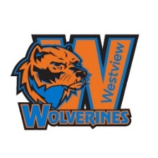
Black Student Leadership Council (BSLC)
Ms. Wilson
- cultivate character and develop leadership by creating, organizing, and hosting culturally relevant projects and events.

Campus Life
Mr. Busby

-weekly opportunities for connection and fun

Pathway Clubs
DECA
Julie Burnett & Kevin Myers

- prepares emerging leaders and entrepreneurs for careers in marketing, finance, hospitality, and management.

Educators Rising
Lynn Wray

-For future Education Professionals
HOSA
Lillian Malcom & Ms. Hawkins

-For future Health Professionals

Other Opportunities
Westview HS Robotics
CSM Shawn Griffith
MAJ Patrick Bauer
-build, code and compete in VEX VRC Robotics competitions

Gay-Straight Alliance
Maggie Heuerman and Jennifer Weeder
-gather to make friends, have fun, and promote an inclusive Westview culture

Coding Club
Julie Burnett
- learn coding fundamentals, including syntax, logic, and problem-solving techniques.

Dungeons and Dragons Club
Mr. Riley Norstrom
-learn how to play cooperative tabletop games with friends, learn to paint miniatures to look real and be in a community

